

Student Name……………………………………

MATHEMATICAL METHODS (CAS) UNITS 3 & 4

TRIAL EXAMINATION 2

2014

Reading Time: 15 minutes
Writing time: 2 hours

Instructions to students
This exam consists of Section 1 and Section 2.
Section 1 consists of 22 multiple-choice questions, which should be answered on the detachable answer sheet which can be found on page 26 of this exam.
Section 2 consists of 4 extended-answer questions.
Section 1 begins on page 2 of this exam and is worth 22 marks.
Section 2 begins on page 10 of this exam and is worth 58 marks.
There is a total of 80 marks available.
All questions in Section 1 and Section 2 should be answered.
Diagrams in this exam are not to scale except where otherwise stated.
Where more than one mark is allocated to a question, appropriate working must be shown.
If a question requires a numerical answer then an exact value must be given unless a decimal approximation is specifically asked for.
Students may bring one bound reference into the exam.
Students may bring into the exam one approved CAS calculator (memory does not need to be cleared) and, if desired, one scientific calculator.
A formula sheet appears on page 25 of this exam.

This paper has been prepared independently of the Victorian Curriculum and Assessment Authority to provide additional exam preparation for students. Although references have been reproduced with permission of the Victorian Curriculum and Assessment Authority, the publication is in no way connected with or endorsed by the Victorian Curriculum and Assessment Authority.

© THE HEFFERNAN GROUP 2014
This Trial Exam is licensed on a non transferable basis to the purchasing school. It may be copied by the school which has purchased it. This license does not permit distribution or copying of this Trial Exam by any other party.
SECTION 1

Question 1

If is a factor of 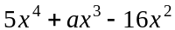 where 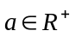, then a is equal to

- – 2
- 1
- 2
- 3
- 4

Question 2

Let 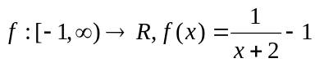.
The range of f is

- 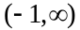
- 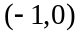
- 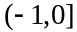
- 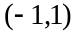
- 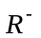

Question 3

The average rate of change, with respect to x, of the function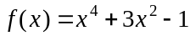 over the interval 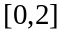 is

- 14
- 22
- 28
- 32
- 44

Question 4

Let 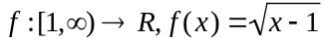 and let 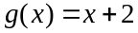. 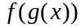 exists if the domain of g is

- 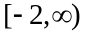
- 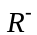
- 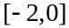
- R
- 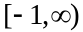

Question 5

Let 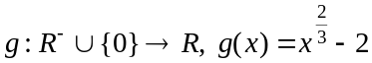.
The graph of 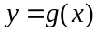 is shown below.
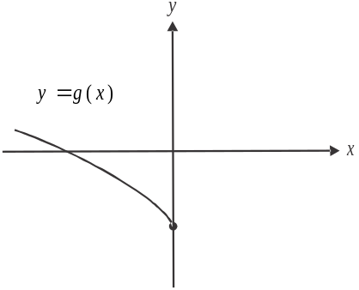

The graph of 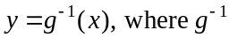 is the inverse of g, could be given by

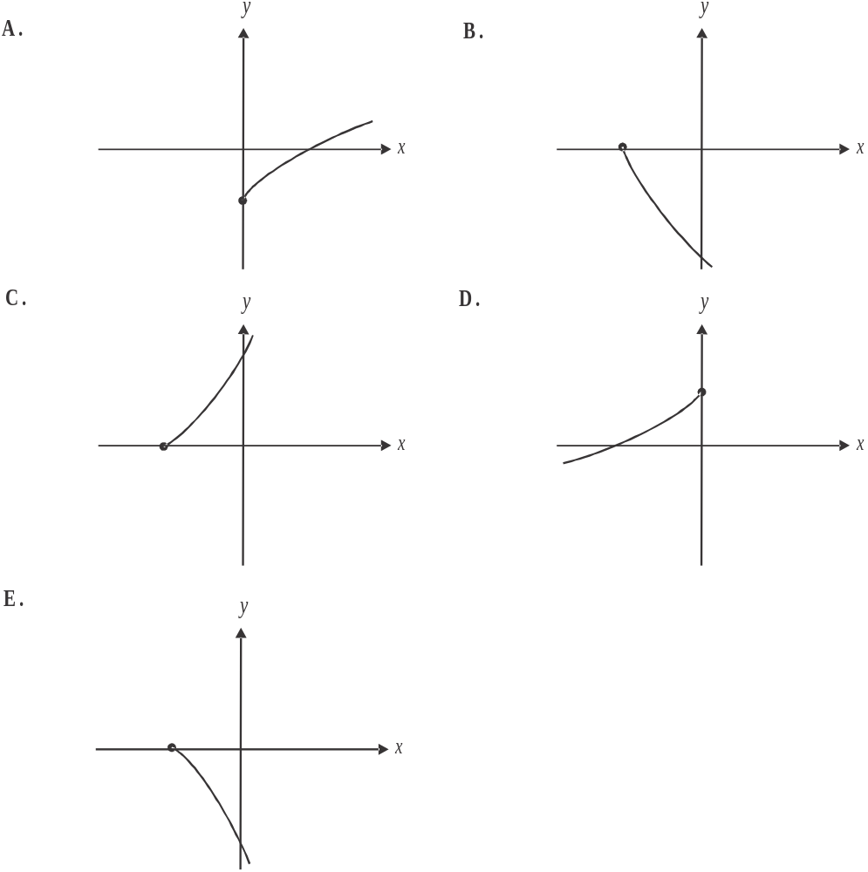

Question 6

The diameter X, in mm, of automotive bolts which are mass produced, is normally distributed with a mean of 12mm and a standard deviation of 0.4mm.
The probability that a randomly selected bolt has a diameter less than 13mm is closest to

- 0.0062
- 0.0438
- 0.4938
- 0.8975
- 0.9938

Question 7

The equation 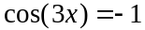 has a general solution given by

- 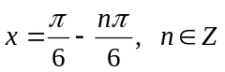
- 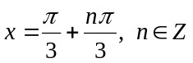
- 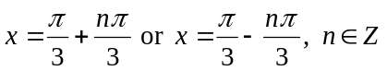
- 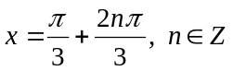
- 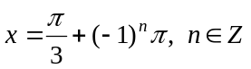

Question 8

The inverse of the function 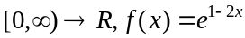 is

- 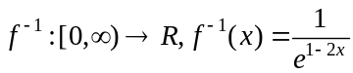
- 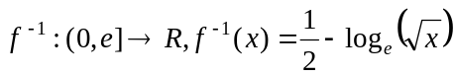
- 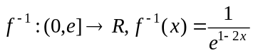
- 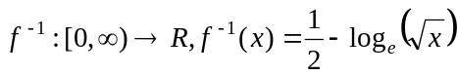
- 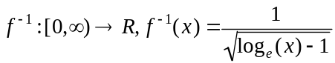
Question 9

For the two independent events A and B, .
The value of p is

- 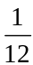
- 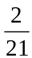
- 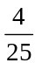

Question 10

Grace has a driving lesson every week. If she drives well one week, the probability that she drives well the next week is 0.6.
If she doesn’t drive well one week, the probability that she doesn’t drive well the next week is 0.3.
Grace didn’t drive well in her first week of taking driving lessons.
What is the probability of her driving well in the third week?

- 0.027
- 0.108
- 0.37
- 0.63
- 0.84

Question 11

The probability density function of the continuous random variable X is given by

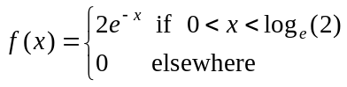

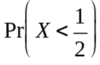 is closest to

- 0.3934
- 0.6065
- 0.7869
- 0.8237
- 0.9142
Question 12

The function f has a maximal domain and satisfies the equation 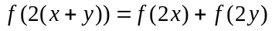, where x and y are any non-zero real numbers.
The rule for f could be

- 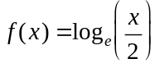
- 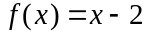
- 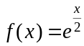
- 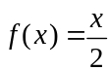
- 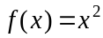

Question 13

The tangent to the graph of 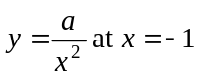 has a y-intercept at 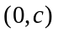. Both a and c are constants and c is equal to

- – a
- a
- 1
- 3a

Question 14

The variable x is a function of t such that 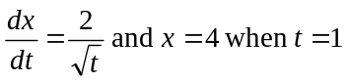.
If 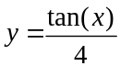, then 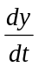 is equal to

- 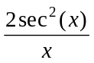
- 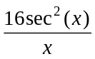
- 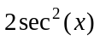
- 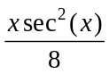
- 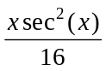
Question 15

A quartic function f has a negative coefficient of its 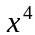 term.

Also, 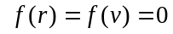

and 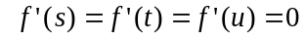

where for these real numbers, .
The graph of 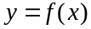 has a positive gradient for

- 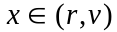
- 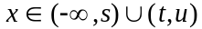
- 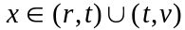
- 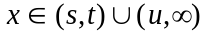
- 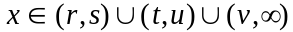

Question 16

Which one of the following functions shown below has an average value of five over the interval 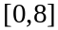.
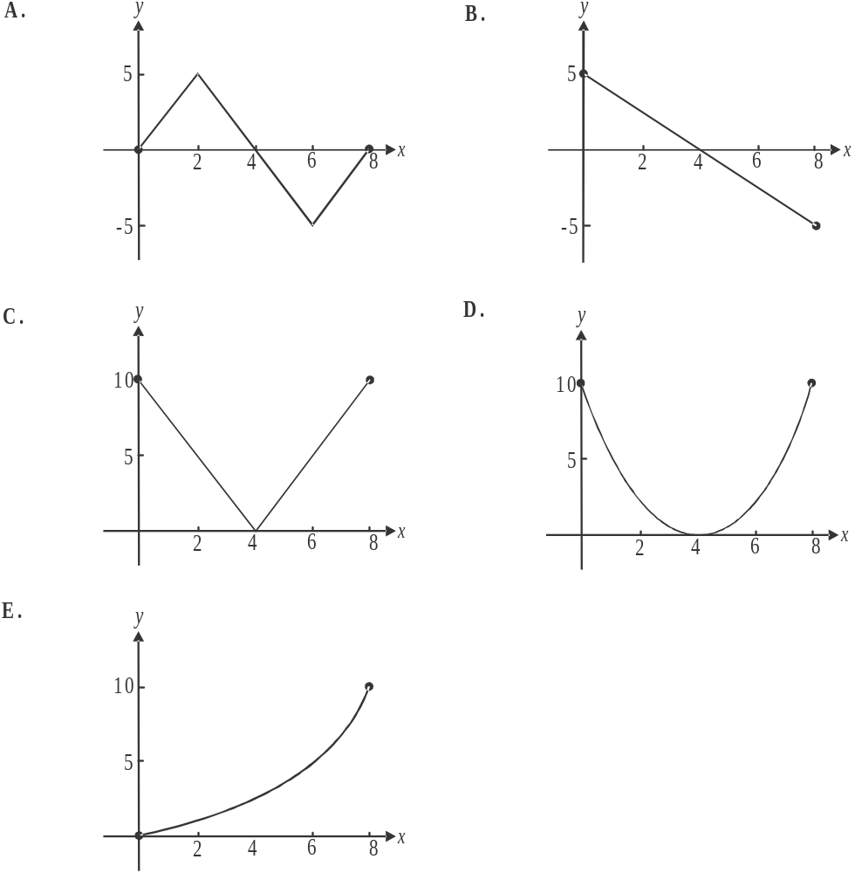

Question 17

Let .
The graphs of the functions f and g are shown below.
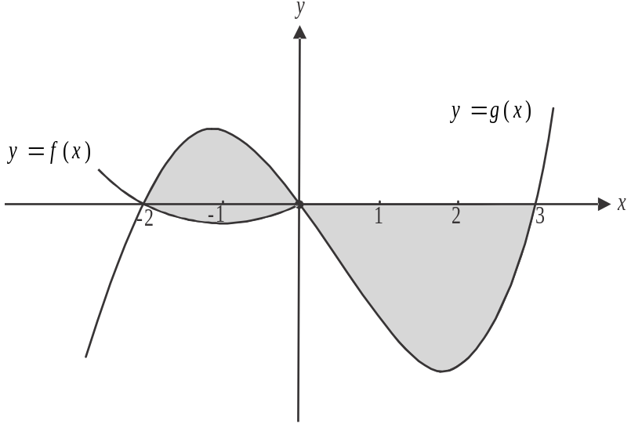

The total area of the shaded region is given by

- 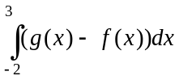
- 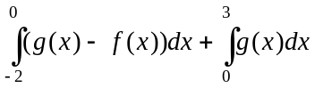
- 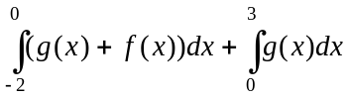
- 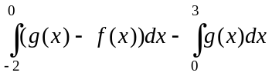
- 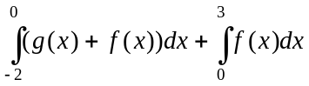

Question 18

The matrix equation below represents a system of simultaneous equations.

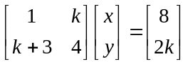

This system will have an infinite number of solutions when

- 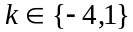
- 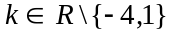
- 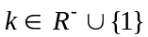
Question 19
Let 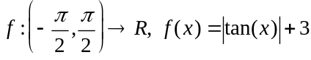.
Which one of the following is true for f ?

- The function f is not defined at .
- The function f is increasing for .
- The gradient function 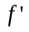 is not defined at .
- The function f is discontinuous at .
- The gradient function is positive for .

Question 20

At Red Top Taxis, the waiting time between when a customer books a taxi by phone, and when the taxi arrives is X minutes. This random variable X is normally distributed with a mean of minutes and a standard deviation of 3.4 minutes.
If a Red Top Taxi doesn’t arrive within 30 minutes of a phone booking being made, then the customer gets a free ride. Red Top Taxis expect that 140 out of the next 2700 customers who make a phone booking will get a free ride.
The mean waiting time in minutes is closest to

- 19.80
- 22.63
- 24.47
- 26.96
- 35.53

Question 21
The function f is transformed according to T where 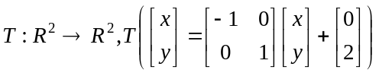.
The rule of the image function of f is 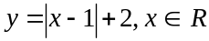.
The rule of function f is

- 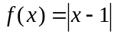
- 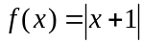
- 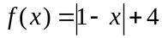
- 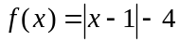
- 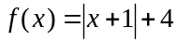

Question 22

The function 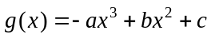, where a, b and c are real constants and 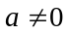, will have more than one stationary point when
- 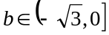
- 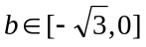
- 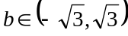
- 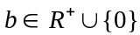
- 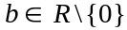
SECTION 2

Answer all questions in this section.

Question 1 (14 marks)

A dry creek bed that follows a curve with equation 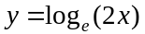, between points A and B, is shown on the graph below.
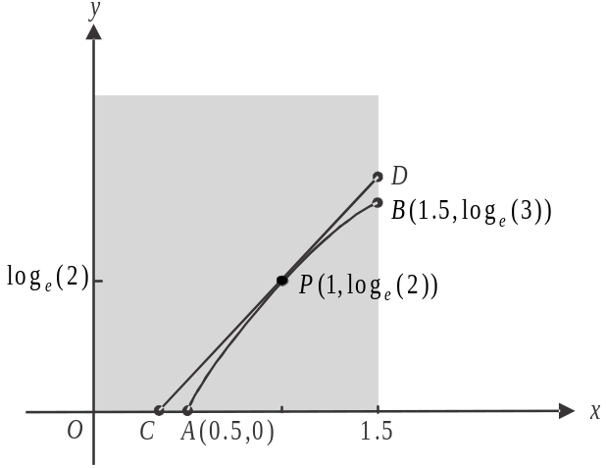

The creek bed runs through a rectangular piece of flat, public land which is shaded in the diagram.
A straight walking track runs between points C and D. The line CD is a tangent to the graph of at the point 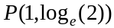.
The unit of measurement is the kilometre and the y-axis runs in a north-south direction.

- i. Show that A is the point 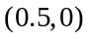 1 mark

- Find 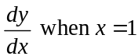. 1 mark

- Show that the x-coordinate of point C is 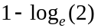. 1 mark

- Show that the y-coordinate of point D is 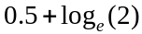. 1 mark

A second straight track is built. It runs from point E at the top corner of the public land to point P. This second track, EP, runs at right angles to CD.
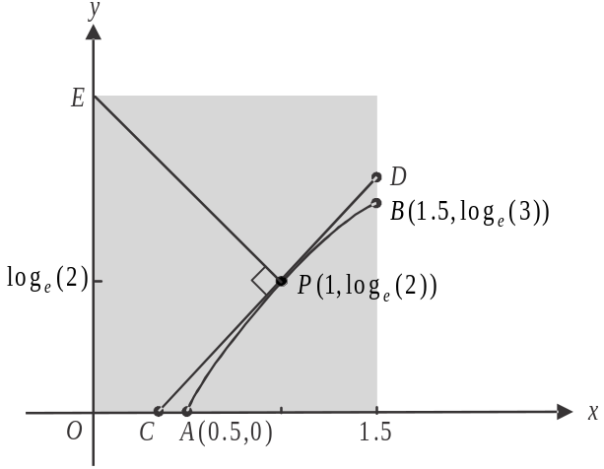

- Find the area of this piece of public land. Express your answer as an exact value in square kilometers. 2 marks

In order to create a bike track as well as a pedestrian track, local council plans to build a straight track that would run from point A to point B.

- i. Show that the equation of this straight track AB is 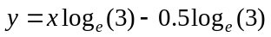. 2 marks

- Find the maximum distance, in the north - south direction, between the dry creek bed and this new straight track between A and B. Express your answer in kilometers correct to 2 decimal places. 3 marks

The local council is considering replacing the dry creek bed with a barrel drain. The position of this drain would be slightly different to the current position of the dry creek bed.

One model for the position of the new drain is obtained by dilating each point on the line 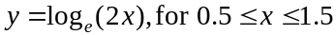 by a factor of n from the x-axis and by a factor of q from the y-axis.

Point would become point 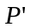 according to this transformation where is the midpoint of CD.

- Find the values of n and q. Express your values correct to two decimal places. 3 marks

Question 2 (16 marks)

Residents in a Melbourne suburb have access to weekly kerbside collections of general waste bins, recycle waste bins and green waste bins.
There are 30 households in a particular street in this suburb.

The probability that a randomly chosen household in this street puts a general waste bin out for collection in any given week is 0.9. This is independent of whether other households put their bin out for collection.

- i. Find the probability that during a particular week, four randomly selected households in the street have put their general waste bin out for collection. 1 mark

- Find the probability that at least 25 households in this street put their general waste bin out for collection one week.
Express your answer correct to 4 decimal places. 2 marks

- Find the probability that more than 28 households put their general waste bin out for collection one week, given that at least 25 households put their general waste bin out for collection that same week. Express your answer correct to 3 decimal places. 3 marks

Darren is minding his mate’s place and is a resident in the street for 10 weeks.
If he puts the recycle waste bin out for collection one week, the probability he will put it out the next week is .
If he doesn’t put it out one week, the probability he will put it out the next week is .
Darren put the recycle waste bin out for collection in his first week in the street.

- i. Find the probability that Darren puts the recycle waste bin out for collection at least once in the following three weeks. 2 marks

- Find the probability that Darren puts the recycle waste bin out for collection in his last week in the street. Express your answer correct to 3 decimal places. 2 marks

- Let p represent the probability that any resident in the street puts their green waste bin out for collection in any one week, independently of whether their neighbours do.
The random variable Y represents the number of households in this street of 30 households who place their green waste bin out for collection in any one week.
Show that 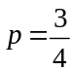, given that 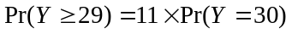. 2 marks

- The time, taken, in seconds, for the collection truck to lift, empty and reposition each green waste bin in the suburb is given by the random variable X which is normally distributed.
As it happens, where Y is the random variable described in part c.
Find correct to 2 decimal places, the mean and the standard deviation of the normal distribution. 4 marks

Question 3 (15 marks)

Victoria James is a spy.
She is on a mission to retrieve a bomb that has been dropped into a large tank at a nuclear plant.
The 30 metre high tank, which is shown below, has pipes attached and a liquid chemical is pumped in and out.

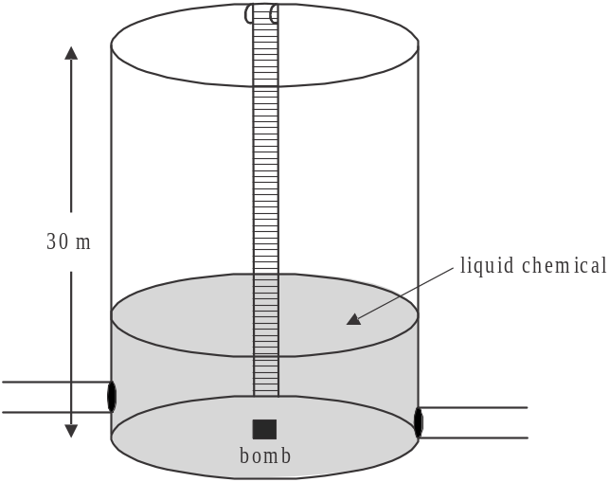

The height, h, in metres of the liquid chemical at time t hours, is given by

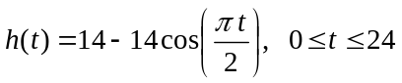

where corresponds to the time when Victoria enters the tank.

- For the function h, find

- the amplitude. 1 mark

- the period. 1 mark

Victoria enters the tank via an internal ladder. She has six hours to reach the bomb and pack it up so that she can carry it back up the ladder to a bomb disposal expert waiting at the top.
Victoria can only safely reach and pack the bomb when the height of the liquid chemical is less than one metre.

- i. How long after Victoria enters the tank is the height of the liquid chemical first one metre? Express your answer in minutes correct to 2 decimal places. 1 mark

- Find the total time available, during the six hours Victoria has available, when she can safely reach and pack up the bomb. Express your answer in minutes correct to 2 decimal places. 2 marks

After safely reaching and packing the bomb, Victoria stands at the bottom of the ladder. The speed V, in m/s, at which she can climb up the ladder, is given by the function

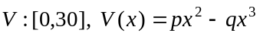,

where x is the distance, in metres, of Victoria’s feet from the bottom of the ladder and p and q are positive integers.

When Victoria reaches the top of the ladder, 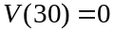

- i. Express p in terms of q. 1 mark

  - Show that Victoria’s speed when she is 20 metres up the ladder is twice her speed when she is 10 metres up the ladder. 2 marks

  - Find the value of x when Victoria’s speed is a maximum. 2 marks

The value of p is affected by the strength of the fumes given off by the liquid chemical.
The relationship between p and q remains the same regardless of the value of p.

- If 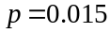, find the maximum speed, in m/s at which Victoria can move up the ladder. 2 marks

The stronger the fumes the more quickly Victoria moves up the ladder. However, if her maximum speed exceeds m/s, then the bomb will explode.

- Find the values of p such that the bomb does not explode. 3 marks

Question 4 (13 marks)

The graph of the function 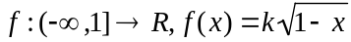 where k is a positive integer, is shown below.
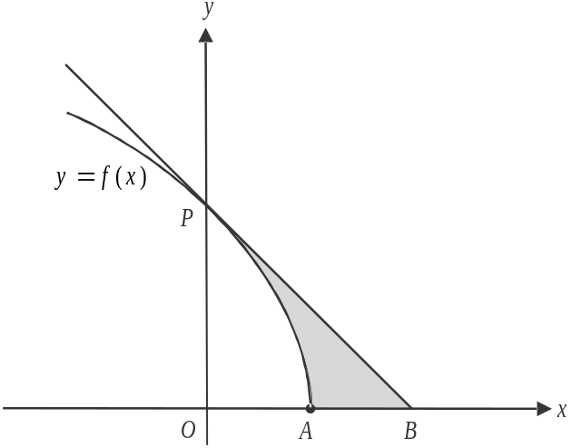

Point P is the y-intercept of the graph of f. The tangent to the graph of f at point P has its x-intercept at point B as shown.

- Find the equation of the tangent to the graph of f at point P, in terms of k. 2 marks

- Show that B is the point 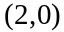. 1 mark

- The shaded region in the diagram is enclosed by the graph of f, the tangent at point P and the x-axis.
Find, in terms of k, the area of this shaded region. 2 marks

- The average value of function f between 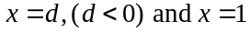, is k.
Find the value of d. 2 marks

The normal to the graph of f at point P intersects with the line at the point C.

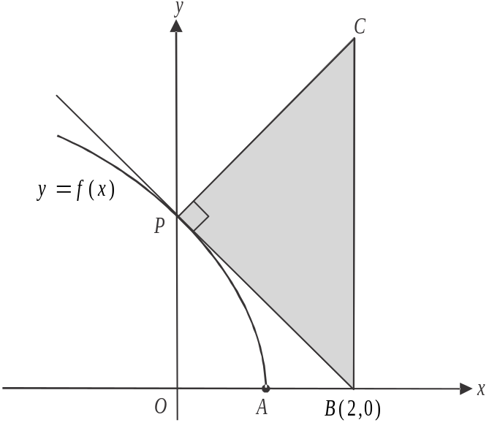

- The area of , expressed in terms of k, is given by 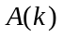.
Show that 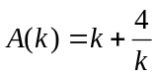. 4 marks

- Find 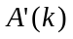. 1 mark

- Find the minimum area, in square units, of . 1 mark

Mathematical Methods (CAS) Formulas

Mensuration
area of a trapezium: 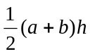 volume of a pyramid: 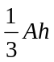
curved surface area of a cylinder: 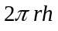 volume of a sphere: 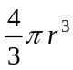
volume of a cylinder: 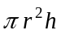 area of a triangle: 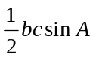
volume of a cone: 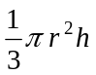

Calculus
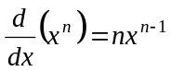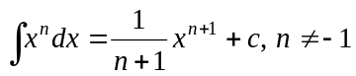
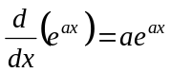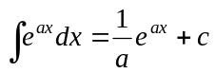
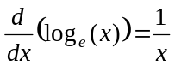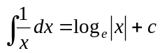
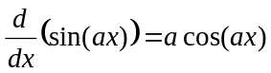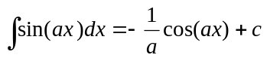
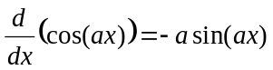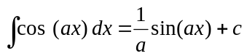
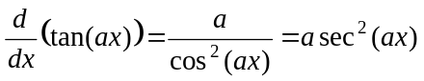
product rule: 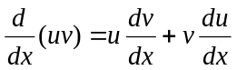 quotient rule: 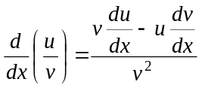
chain rule: 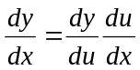 approximation: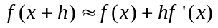

Probability
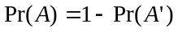
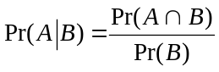 transition matrices: 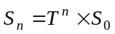
mean: 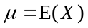 variance:

probability distribution |  | mean | variance
discrete | 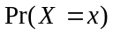=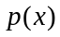 | 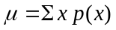 | 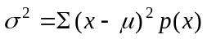
continuous | 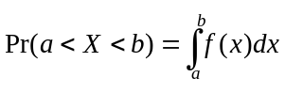 | 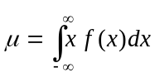 | 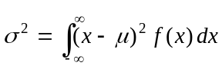

Mathematics Formula Sheets reproduced by permission; © VCAA 2013. The VCAA does not endorse or make any warranties regarding this study resource. Current and past VCAA VCE® exams and related content can be accessed directly at www.vcaa.vic.edu.au
